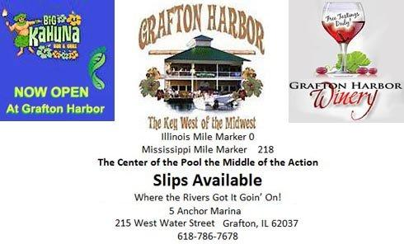

Grafton Harbor
2010 Calendar of Events

Sat. May 1, 2010 4:00 PM Derby Party
Tim and Val’s Annual Derby Party at the BIG KAHUNA
Ladies and Gentlemen Place Your Bets * Music by Lisa Jones * Ladies Decorate Your Hats!
Join us for Appetizers and an Evening of Fun.

Wednesday, May 5th Cinco de Mayo
Mexican Fiesta Time!
$2.00 Margaritas and Great Mexican Food!
5:00 P.M. Oley!

Saturday, May 15 Grand Opening of the
BIG KAHUNA
12:00 PM—7:00 PM Fish Fry
1:00 PM Ribbon Cutting
2:00 Kids Gold Hunt
Live Entertainment
8:00 PM Big Kahuna Look A like Contest
$100.00 Grand Prize ($10.00 Per Participant)

Saturday, May 15—BIG KAHUNA
Made to Order Breakfast Begins

Saturday, June 12 – National Marina -
4th Annual Dock Hop
Hey Cats and Kittens, you can’t lose, put on your poodle skirts and blue suede shoes.
Come on down and don’t be late,
It’s time to Rock and Roll and Celebrate!
Listen closely to the drill & the whole night will be quite a thrill!
H Dock will serve Cocktails at 6:30 PM on H Dock
F Dock will serve Appetizers at 7:15 on F Dock
E Dock will serve Cocktails at 7:45 on E Dock
C Dock will serve Appetizers at 8:15 on C Dock
A, B & I Docks will serve After Dinner Drinks & Desserts on B Dock.
Live Entertainment following at the Big Kahuna

Saturday and Sunday June 19 and 20
Tow Boat Festival The Loading Dock

Saturday, June 26
The Great Grafton Pub Crawl
Theme: The Caribbean Crawl
12:00PM—10:00PM
Buses run from 6:00 PM—10:00 PM
Drink Specials - Food Specials – Entertainment

Saturday, July 17 Blessing of the Fleet
2:30 PM Pirate’s of the Mississippi
Con Trios Party following Parade

Saturday, July 31 - The Big Kahuna Harbor Rodeo
Pool Side 6:30 PM
Tom Toms Famous BBQ – Rodeo Games & Live Music

Saturday, August 21 Hawaiian Luau Shrimp Boil
Live Music and Shrimp Boil begins at 7:30
Poolside
Just roll-up your sleeves, spread out the newspapers and enjoy piles of steaming delicious shrimp.

Saturday and Sunday Sept. 11 and 12
Grafton’s 5th Annual Art Festival

Saturday, Sept. 18, 2010 9-11 Boat Parade
The boaters of Pool 26 have been invited by the Department of National Affairs to celebrate National POW/MIA Day on Saturday, September 18, 2010.
This event will be celebrated along with our annual 9-11 Boat Parade. This event starts at the Grafton Harbor with an opening ceremony beginning at 12:00 p.m. with the Blessing of the Fleet and Boat Parade following at 2:15.
Please help us honor our Nation's POW's, MIA's, those who lost their lives on 9-11 and those who fight to keep our nation safe.
Award Flags and Trophies will be
Awarded for Most Patriotic - 1st, 2nd, and 3rd Place
Fish Fry, Live Music, and other Festivities will begin at 11:00.

Saturday and Sunday Oct 2 and 3
St. Patrick’s Fall Picnic
Great Food, Live Entertainment, Games, Raffles,
Beer Wagon, Craft Store and MUCH MORE!

Saturday Oct. 16 and Sunday Oct. 17
The Great Grafton Rendezvous
Black Powder Shoot O Hawk & Knife Throw O Primitive Bow Shoot O Artisans/Traders
Authentic Foods O Children’s Activities O Time Period Music O Raffle

Saturday, Oct. 23
Fall Classic Boat Parade
Gathering at Grafton Harbor - 12:00

Saturday, Oct. 30 – Halloween Party
Prizes & Live Entertainment 8:00
215 West Water Street
Grafton, IL 62037
Illinois Mile Marker 0
Mississippi Mile Marker 218
Grafton Harbor 618-786-PORT (7678)
BIG KAHUNA 618-786-HULA (4852)

