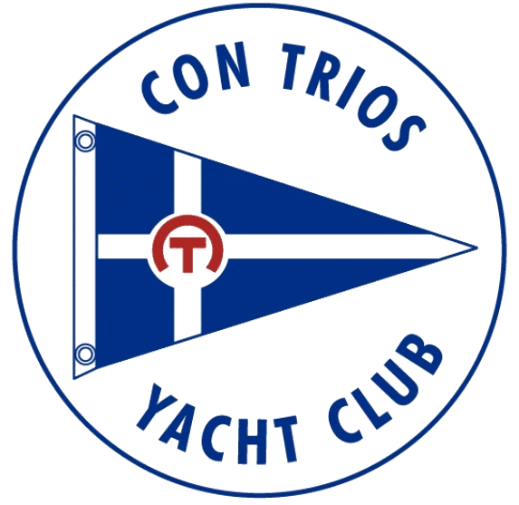
Con Trios Yacht Club
Goofy Golf

Participant Name: Marina:
Participant Phone Number: Email:

The Alton Marina
Hole 1:
Hole 2:

The Boathouse
Hole 1:
Hole 2:

Grafton Harbor
Hole 1:

Longshot Tiki Bar
Hole 1:
Hole 2:

Yacht Club of Saint Louis
Hole 1:
Hole 2:

Fast Jax - :
Mulligan Hole:
Hole to Replace:

Total:

Day of Event:
- Start
  - You may start at any of our participating locations-be sure to verify that they’re open first!
  - You can pay online or with the Fleet Captain the day of the event.

- Game: At each location, you'll complete the putt(s) attempting to get the lowest score possible.
  - At your final location, turn in your score sheet, or give it to the Fleet Captain.
  - FC will collect score sheets from all locations, verify entry & tally results.
  - Winners will be announced via CTYC’s FB page, CTYC’s website & email.

    - Fast Jax-Mulligan Hole (636-699-5716)
    - Yacht Club of Saint Louis- 2 Holes (636-250-4435)
    - The Boathouse Food & Deck – 2 Holes (636-250-3300)
    - Grafton Harbor – 2 Holes (618-786-7678)
    - Longshot Tikki Bar – 2 Holes (636-795-2244)
    - The Alton Marina – 2 Holes (6618-462-9860)

- Prizes: $100 for 1st Place, $50 for 2nd, $25 3rd Place

- Party with a Purpose: Each location will be hosting a special food, drink, raffle or activity with a common goal of raising money for Youth In Need. You can also give a donation to the FC on the day of the event.

- Weather: Event will take place rain or shine - all locations can be visited by land, just be sure to have a DD for the day!

- Please keep in mind that many bars & restaurants are currently short staffed & are doing the best they can! Please be patient with them & any inconveniences you might encounter. We're grateful for their participation & want them to collaborate with us on future club events!

- Contact Fleet Captain with any questions or concerns (jess.r.mckay@gmail.com or (636) 541-7534.

