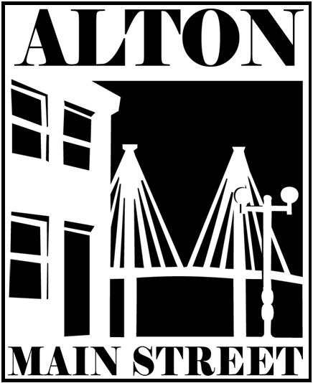
Media Release

Alton Main Street
Contact: Sara McGibany, Executive Director
219 Piasa Street, Suite 2B - Alton, IL 62002
Phone: 618-463-1016
Email: Sara@AltonMainStreet.org
Web: www.DowntownAlton.com

FOR IMMEDIATE RELEASE

Join Alton Main Street to kick off the holiday season on Friday, Nov 19th
at the 27th Annual Tree Lighting in Downtown Alton!

(17 Nov 2021 - Alton, IL) On Friday, November 19th Alton Main Street will host an event that’s sure to get you into the holiday spirit. The 27th Annual Community Tree Lighting at Lincoln-Douglas Square will begin with the arrival of Santa and Mrs. Claus on the trolley at 6:00. The free festivities including caroling, cookies and hot cocoa will continue until 6:45 when Mayor David Goins flips the lights on the beautiful tree, which is provided by the Alton-Godfrey Rotary Club. Families are encouraged to bring their cameras to take pictures with Santa and costumed holiday characters.

Songs will fill the air throughout the evening provided by area Girl Scout Troops, and the Great Rivers Choral Society. Reverend Sheila Goins of the Morning Star Missionary Baptist Church will bless the tree. Other speakers include Rotary Club President Steve Schwartz, and Salvation Army Captain Cassy Grey, who will be kicking off the “Tree of Lights” campaign with 2021 Chairpeople Taylor and Lily Freer. The MC for this community event will be Chris Miller, Vice President of Alton Main Street.

Visitors can check out the Salvation Army’s Big Red Kettle during the event, and the public is encouraged to help the less fortunate by bringing non-perishable food donations to the event to benefit the food pantry at the Salvation Army. The items will be constructed into a giant “Castle of Cans” at the foot of the Lincoln and Douglas statues during the event. Families are also welcome to create holiday crafts during the event with the Madison County Child Advocacy Center.

Between the hours of 5:30-7:30, free trolley transportation will be provided between Lincoln-Douglas Square and the Riverbender.com Community Center, located at 200 W. 3rd Street. Following the Tree Lighting, the public is invited to the Community Center’s Holiday Open House to play games, make crafts, visit with Santa & Mrs. Claus and warm up with refreshments indoors until 10:00 p.m. Don’t miss the Great $25,000 Toy Giveaway sponsored by Riverbender.com and Hit-n-Run Food Stores which will take place at the Riverbender.com Community Center’s Open House; every child who attends will be given a toy.

Free horse and carriage rides will be offered from 7:00-9:00 p.m., departing from the corner of 3rd and Belle Streets. Families can enter a drawing to ride in the carriage with Santa from the Square to the Community Center by posting their favorite photo from a prior Tree Lighting – details on how to enter can be found at www.facebook.com/AltonMainStreet.

The public is encouraged to make a night of it and enjoy the fun activities in the district while patronizing the downtown merchants and restaurants for their holiday shopping and dining. You can find more information on the many ways the Alton Main Street is working to promote and advance the historic district, as well as ways to get involved on their website: www.DowntownAlton.com.

Alton Main Street would like to thank the following sponsors who have made this event possible: Illinois American Water, Phillips 66 Wood River Refinery, Alton Memorial Hospital, CNB Bank & Trust, 1st Mid-America Credit Union, Poputopia Gourmet Popcorn and Sweets, Picture This & More, Sam's Loans, Sheppard, Morgan & Schwaab, Chiro One, The Salvation Army, Alton-Godfrey Rotary Club, Great Rivers & Routes Tourism Bureau, OSF Saint Anthony's Health Center, City of Alton, Riverbender.com, The Telegraph, WBGZ Radio and AdVantage.
# # #

Alton Main Street – engaging our community in the continued renewal of our historic downtown district and Mississippi River heritage by cultivating an attractive center of economic and social activity.

