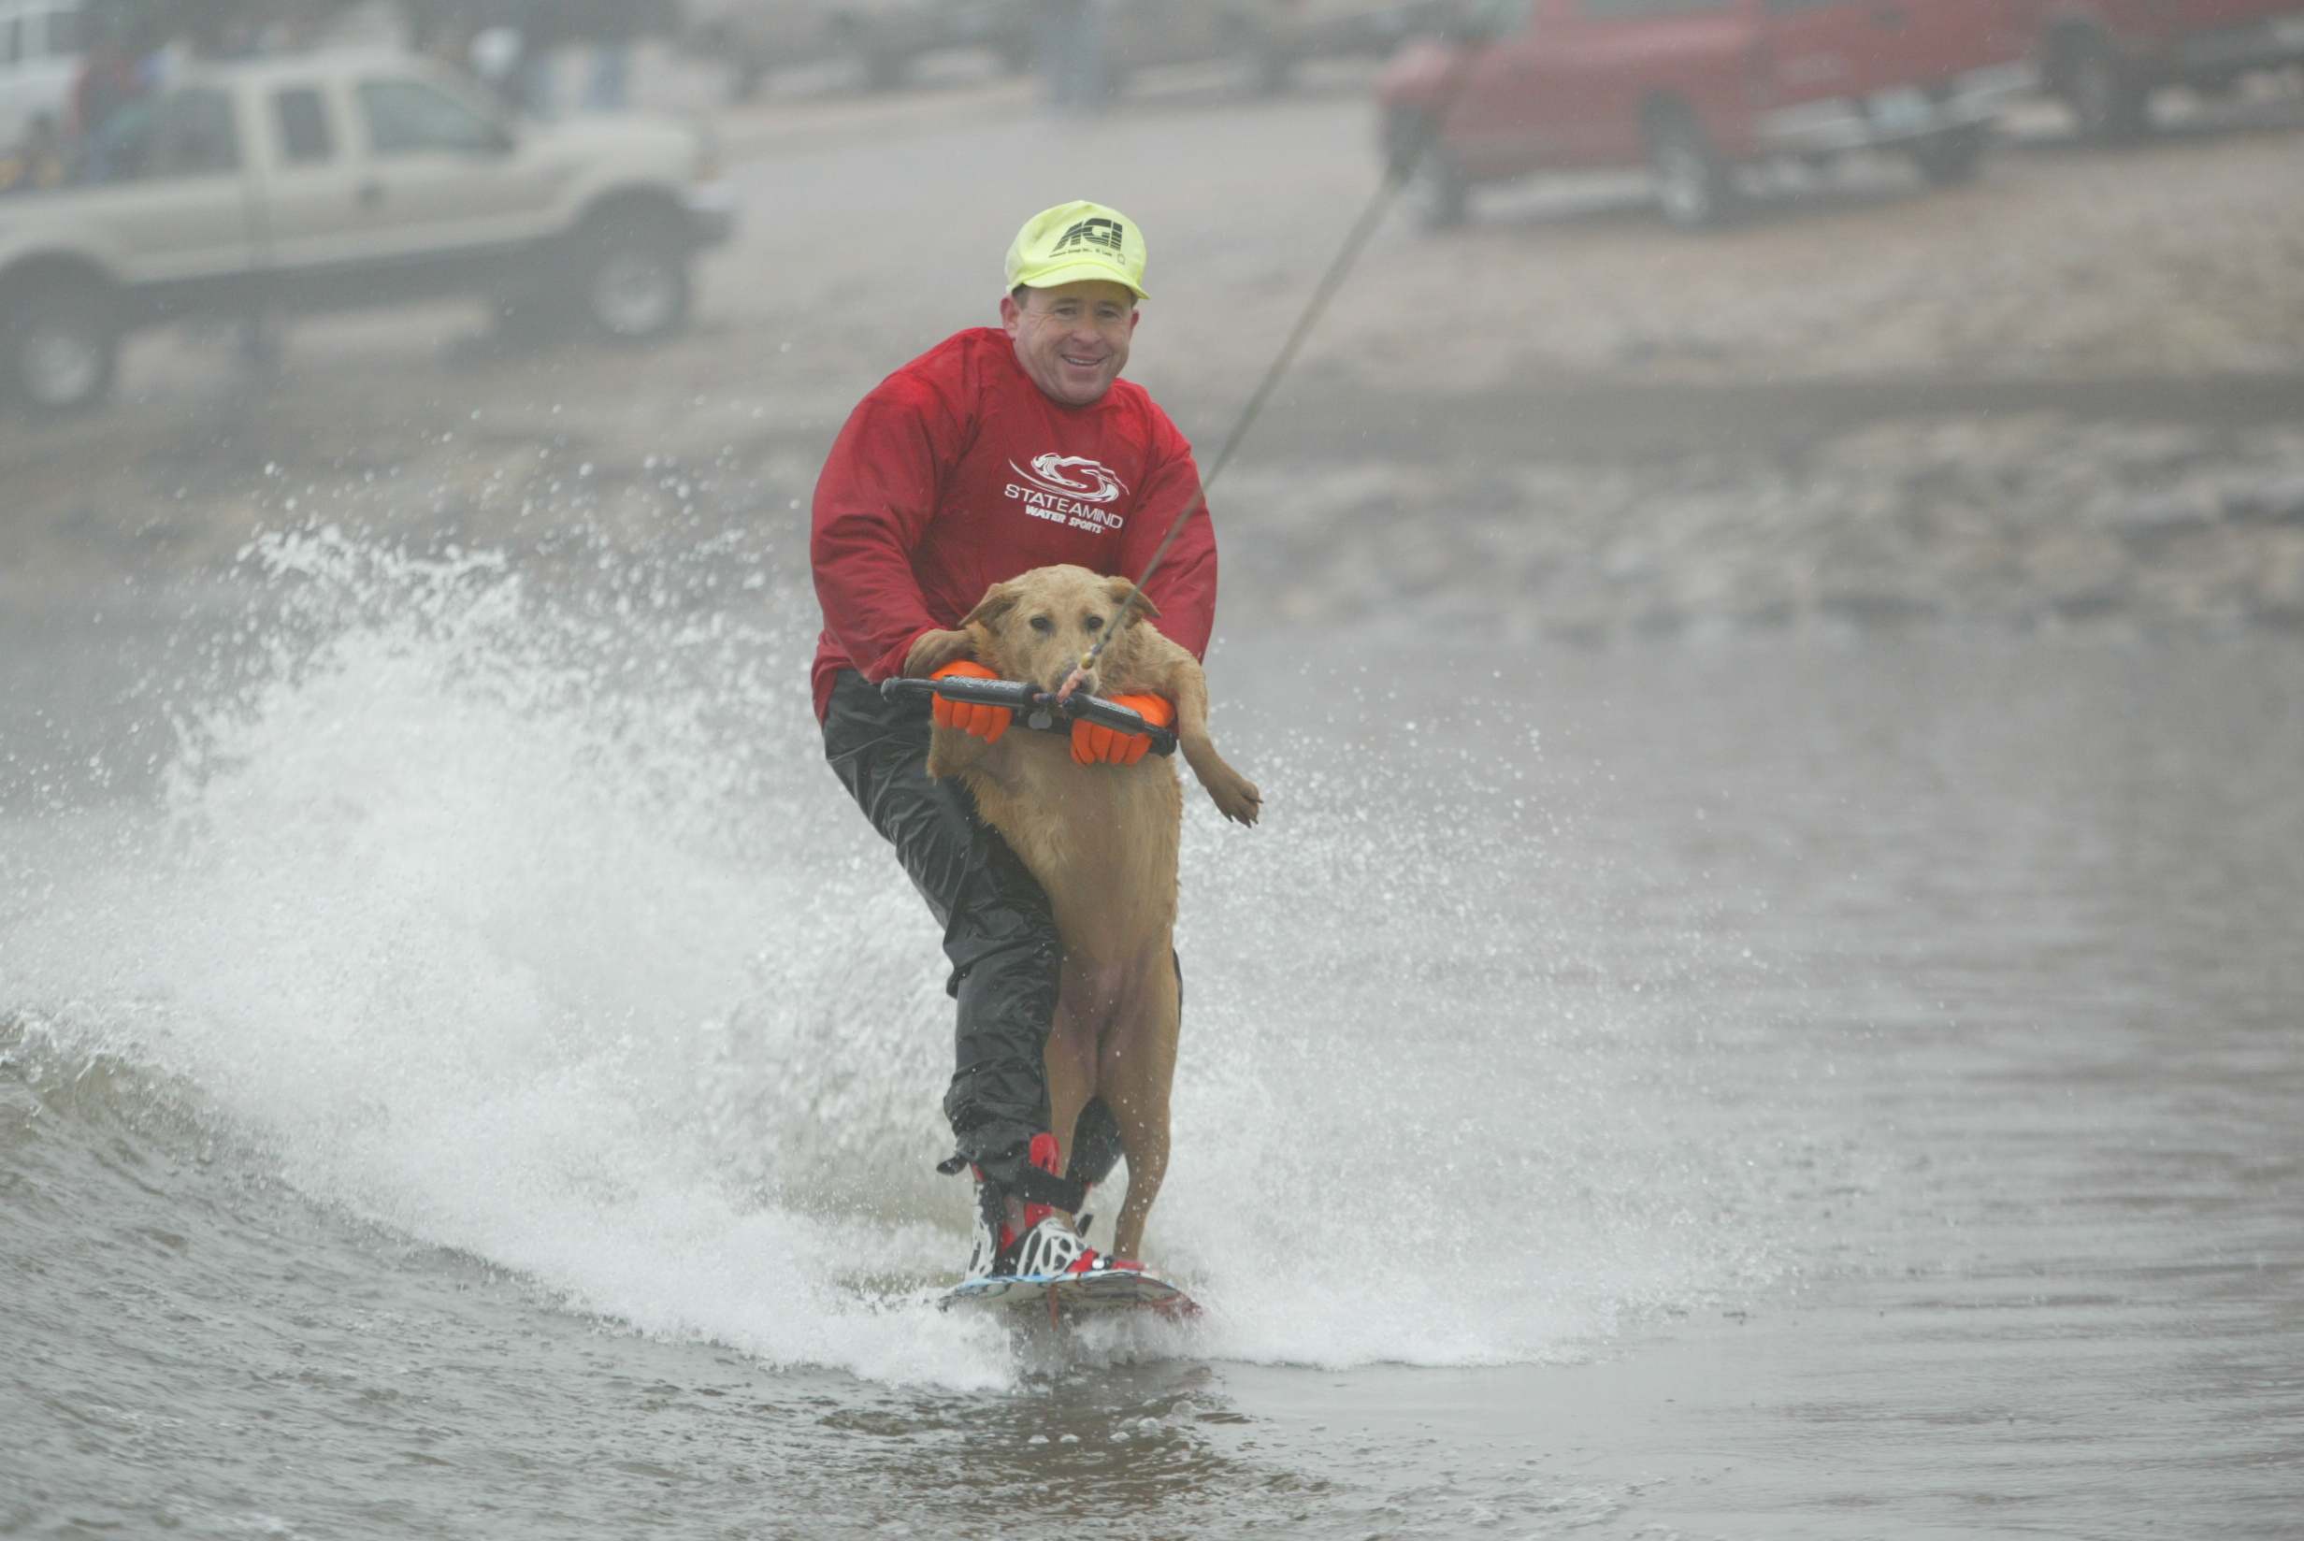
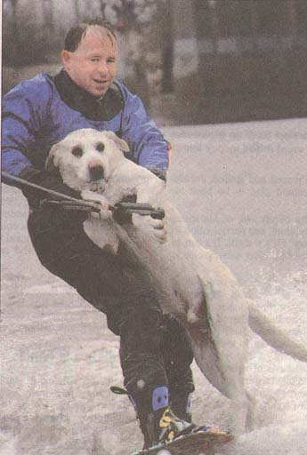
December 14, 2021

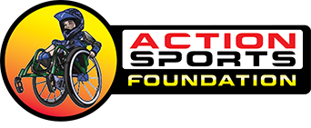

WATERSKIING CLEARWATER

Although I have been skiing on New Years Day for 36 years, Can you believe it, THIS WILL BE MY 1ST ANNUAL POLAR BEAR WATERSKI FUNDRAISER in the Florida Area. This year we will raise $$$ Money to help improve the lives of Disabled Individuals through their involvement with ACTION SPORTS FOUNDATION, a 501c3 charitable organization located in the Tampa Bay Area.

Action Sports Foundation, also known as ASF Adaptive Sports, helps improve the lives of disabled athletes and individuals through their participation in various Adaptive Action Sports including WCMX, known as Wheelchair Motocross or Chair Skating, which is an adaptive action sport, similar to BMX and Skateboarding. ASF provides daily adaptive fitness training programs for both youth and adult special needs community at Me & U Abilities Academy, located in Largo, FL.

I want to wish you all a Very Merry Holiday Season. I will continue the annual tradition of Water Skiing with Santa. This will be my 36th year waterskiing to promote fundraising for DISABLED Athletes. In the past I have performed in St Louis skiing in air temperatures ranging for negative 23 degrees to 55 degrees on New Years Day. I feel Florida will be a much easier challenge on the water, but just as much fun!

This will be my 36th year water-skiing, we will take to the water at 12 noon January 1, 2021 on the Beach at the Clearwater Community Sailing Center. This year I will be raising money for Action Sports Foundation which is a 501c-3 CHARITY. Please CONSIDER YOUR DONATIONS NOW before 12/31 FOR THE 2021 TAX SEASON Deduction as this is a legal deduction and the organization is a 501-C3 Tax Exempt. A donation receipt will be provided for your tax records.

Action Sports Foundation is a 501(c) (3) non-profit corporation dedicated to improving the physical condition & quality of life for the disabled through participation in sports. The organization works with individuals who have acquired spinal chord injuries involving paraplegia, & quadriplegia, spina bifida, orthopedic disabilities, that include amputations, hip & knee replacements, cerebral palsy, head injury, fibrous dysplasia (bone tumors), polio and other neuro-muscular disorders.

My fulfillment is so complete when I am able to assist, teach and get these disabled athletes up on water skis. They are so excited and it’s a joy to see the expression on their faces as the glide across the water.

Any Donation is welcome, but I am asking you to consider becoming a SPONSOR of my event with a donation of $100.00. Please join me in a cause which benefits many Tampa Bay Area Disabled individuals, by supporting my efforts to fulfill the dreams of many disabled individuals. Last year I raised $8700.00 in 2020 and would love to break the $10,000.00 mark this year. Please check with your company, friends and fellow workers in giving some small donation for this cause. Any little bit helps!! . You can make checks payable to ACTION SPORTS FOUNDTION. Checks or money should be sent to Kevin Day 101 Marina Del Rey Ct Clearwater FL 33767.

If your looking for fun, I Dare You, to come to the Clearwater Sailing Center Beach Area Arch Grounds at 11:45 AM New Years Day as a Skier or Spectator. For you chickens just watch for us on TV during the evening news on New Years Day. Don’t forget the Party following the skiing at my house with Homemade Soup.
God Bless You for your help !!!

MAKING IT LOOK EASY
KEVIN DAY & HIS PARTNER JET SKI
NEW YEARS DAY
32 DEGREE WATER TEMPS
DID SOME ONE SAY COME IN????

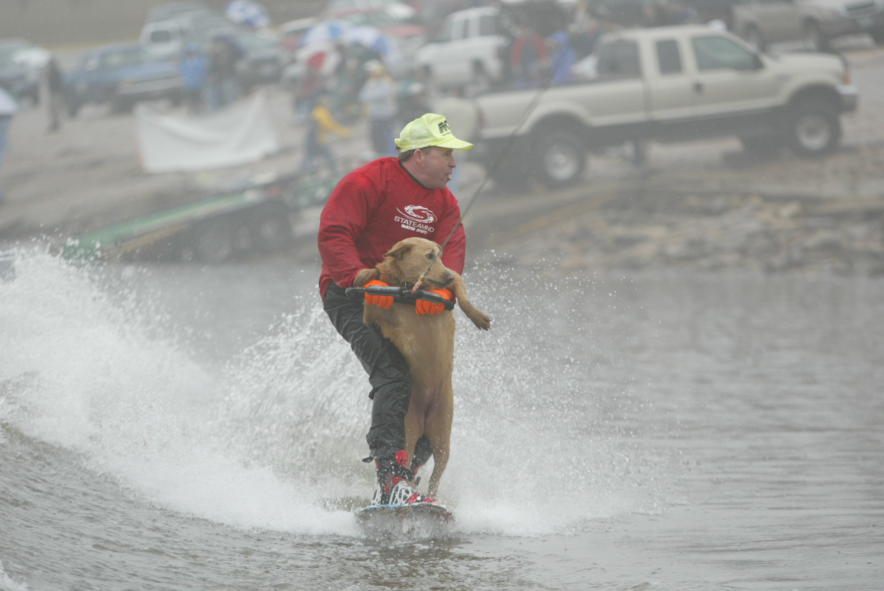
KEVIN DAY & HIS PARTNER BROWN SUGAR

NEW YEARS DAY 2005
34 DEGREE WATER TEMPS

