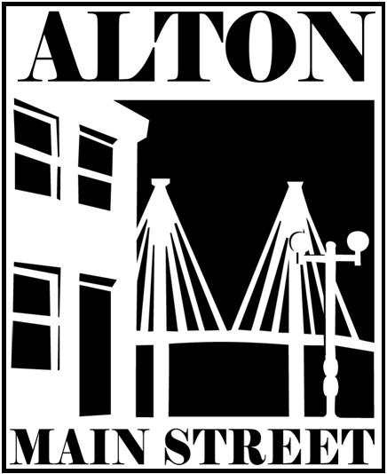
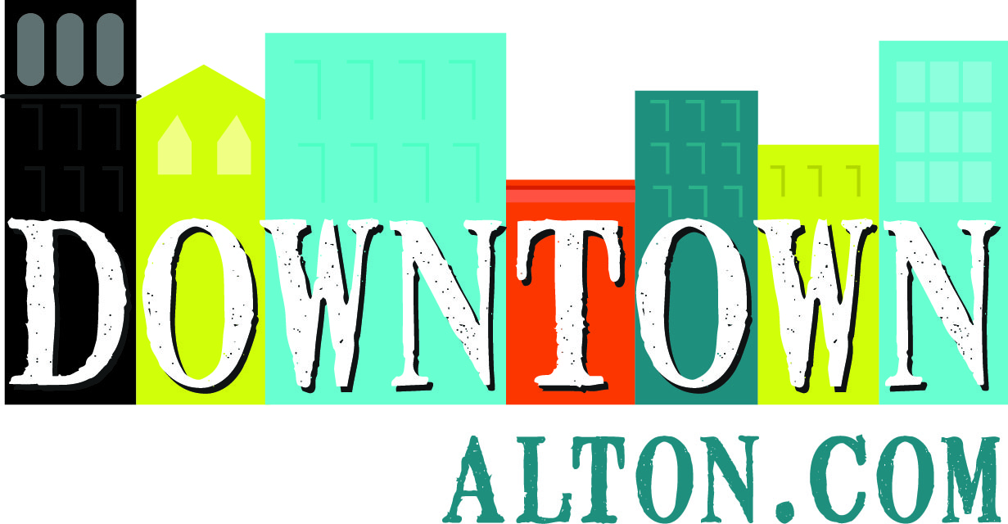
Media Release

Alton Main Street
Contact: Sara McGibany, Executive Director
111 E. 4th St., Suite 315 - Alton, IL 62002
Phone: 618-463-1016
Email: Sara@AltonMainStreet.org
Web: www.DowntownAlton.com

FOR IMMEDIATE RELEASE

Alton Man Street announces new “Eat Shop Play Alton” promotion

(1 July 2022 - Alton, IL) Alton Man Street is announcing its new Eat Shop Play Alton promotion to support Alton’s locally-owned businesses and help customers find their new favorite places to shop small.
To take part, simply stop by the information booth at the Alton Farmers’ & Artisans’ Market to pick up a free reusable Alton-branded shopping bag. The market is located at the corner of Landmarks Blvd. and Henry Street in Downtown Alton, and takes place every Saturday morning between 8:00 a.m.-12:00 p.m. through October 15th. Customers can then present their bag at all of the stores, restaurants and service businesses found at www.DowntownAlton.com/EatShopPlay to redeem their perks and special offers through December 31st.

Shoppers are encouraged to post a photo using their bag at a local business on social media with the hashtag #EatShopPlayAlton for a chance to win a $50 gift certificate to any participating businesses. A new winner will be drawn every month through the end of 2022.
“Alton Main Street is investing $10,000 of the State of Illinois’ small business pandemic relief funding into television and digital marketing for this campaign to target customers in the entire St. Louis metro area and drive them directly into the doors of Alton’s small businesses,” said Sara McGibany, Executive Director of Alton Main Street, adding ”Check out our segment on Channel 4’s Great Day St. Louis on our Facebook page: www.Facebook.com/AltonMainStreet.”

Thirty businesses have signed up to participate so far, and all locally-owned Alton-based businesses and local artists are welcome to participate in this promotion; a link to register can be found at www.DowntownAlton.com/EatShopPlay
Participating businesses are as follows:
- A&A Boutique (300 E. Broadway) – 10% off storewide
- Olive Oil Marketplace (108 W. 3rd St.) -15% off first purchase, cannot be combined with other offers
- Granny’s Uniforms, Work Fashions, and More (2525 College Ave.) – 10% off in store items, 5% off ordered items
- Quick Bite (1626 Main St.) – Free scoop of ice cream with hot dog purchase
- VSalon by Valerie (102 W. 7th St. ) – 10% off any service
- Rushmore (11 E. Broadway) – 15% discount storewide
- Soul Sanctuary (1320 Milton Rd.) – 20% off any service
- The Schoolhouse Grill at Senior Services Plus (2603 N. Rodgers Ave. ) – $2.00 off (does not include congregate meals)
- Campbell’s Construction and Restoration (907 E. Broadway ) – 25% off any residential service
- Mom Said No/ Mississippi Hippie (301 E. Broadway) – 10% discount on entire purchase
- Moon Drops (223 Market St.) – 20% off all products
- State Street Market (208 State St.) – Free appetizer at dinner or free cup of soup at lunch with any purchase
- Lieber Vision Center (401 Henry St.) – 20% discount on frame & lenses
- Jacoby Arts Center (627 E. Broadway ) – 10% discount on events, classes and purchases in our Artist Shop featuring unique, handcrafted, wares from local artists
- It’s Raining Zen (301 E. Broadway) – 10% off purchases
- The Soul Asylum (301 E. Broadway) – $5.00 admission
- Picture This & More (17 E. Broadway ) – 15% off one time custom framing project
- Germania Brew Haus (617 E. Broadway) – 10% discount
- The Brown Bag Bistro (318 E. Broadway ) – Buy 1 sandwich, get 1 half off
- Epicurean Fare (4 E. Broadway) – 10% off purchase
- The Ruby Wren Eclectic Boutique (307 State St) – 10% off The Ruby Wren store brands
- Party On Broadway (307 E Broadway) – Make 1 free word Bracelet DIY and Buy 1 pair of Earrings, get one free
- FLOCK Food Truck Park and Bar (210 Ridge Street) – $1 off Shaken Lemonade
- Beall Mansion (407 East 12th Street) – Book a Pampered Getaway for 2 at The BEALL MANSION and receive a FREE Grafton Winery & Brewhaus wine tasting and souvenir tasting glasses OR save $2.00 off the adult admission of our premium 1 hour Mansion Tour
- Mississippi Mud Pottery (310 E. Broadway) – 10% off all in-stock pottery and artwork (excludes custom orders, cannot be combined with other offers)
- River Bend Yoga (100 W. 3rd Street) – 1 free yoga class (workshops and aerial not included)
- Country Meadows and Country Meadows II (401 East Broadway, upper and lower levels) – 10% discount on purchase of $25 or more
- Black Crow Designs (2521 State St.) – 20% off
- Memento Paintings, Artist Jenna Muscarella (online) – 10% off any original artwork or custom artwork

For more information on this project and the many other ways that Alton Main Street is working to
promote and improve the district, please visit www.DowntownAlton.com.

# # #

Alton Main Street – engaging our community in the continued renewal of our historic downtown district and Mississippi River heritage by cultivating an attractive center of economic and social activity.

